***Customer lifetime value (CLV)***

It is one of the most important metrics to measure at any growing company.

Customer lifetime value has intuitive appeal as a marketing concept as it represents exactly how much each customer is worth in monetary terms, and therefore **exactly how much a marketing department should be willing to spend to acquire each customer**,

By measuring Life Time Value (LTV) in relation to [cost of customer acquisition](https://blog.hubspot.com/service/what-does-cac-stand-for) (CAC), companies can measure how long it takes to **recoup the investment required to earn a new customer** -- such as the cost of sales and marketing.

Lifetime value is typically used to judge the worth of the costs of acquisition of a customer. For example, if a new customer costs $200 to acquire and their lifetime value is $350, then the customer is judged to be profitable,

CLV (customer lifetime value) calculation process consists of these steps:

1. **Calculate average purchase value:** by dividing total revenue by the number of purchases over the course of the same period of time.
2. **Calculate the average purchase frequency:** by dividing the number of purchases over the course of the time period by the number of unique customers who made purchases during that time period.
3. **Calculate customer value:** by multiplying the average purchase value by the average purchase frequency.
4. **Calculate average customer lifespan:** by averaging out the number of years a customer continues purchasing from company.
5. Then, **calculate LTV** by multiplying customer value by the average customer lifespan. This gives us an estimate of how much revenue we can reasonably expect from an average customer to generate for our company over the course of their relationship with us.

We had Calculated the Life Time Expectancy by in a Project by Linear Regression Model in the same way CLV can also be calculated**:**

(Method for studying the relationship between a dependent variable and two or more independent variables.)

**REGRESSION**

Regression is a tool for finding existence of an association relationship between a dependent variable (Y) and one or more independent variables(X1,X2,…,Xn) in a study. The relationship can be linear or non-linear.

• Mathematical relationship is an exact relationship. Y = β0+ β1X

• Statistical relationship is not an exact relationship. Y = β0+ β1X + e (This is the Population Regression Function)

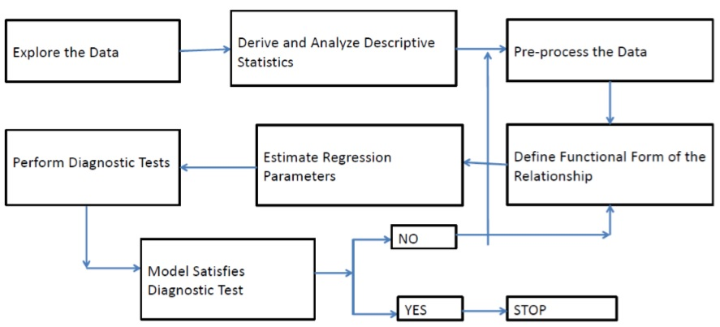

**Assumptions:**

Regression is a parametric approach. ‘Parametric’ means it makes assumptions about data for the purpose of analysis. Due to its parametric side, regression is restrictive in nature. It fails to deliver good results with data sets which doesn’t fulfill its assumptions. Therefore, for a successful regression analysis, it’s essential to validate these assumptions

* Independence: the scores of any particular subject are independent of the scores of all other subjects
* Normality: in the population, the scores on the dependent variable are normally distributed for each of the possible combinations of the level of the X variables; each of the variables is normally distributed
* Homoscedasticity: in the population, the variances of the dependent variable for each of the possible combinations of the levels of the X variables are equal.
* Linearity: In the population, the relation between the dependent variable and the independent variable is linear when all the other independent variables are held constant.

**MLRM Model Diagnostics**

* Test for overall model fitness (R-Square and Adjusted R-Square)
* Test for overall model statistical significance (F test test)
* Test for statistical significance of individual explanatory variables (t test)
* Test for Normality and Homoscedasticity of residuals
* Test for Multi-collinearity and Auto Correlation
* Checking the MAPE (mean percentage absolute error)
* Actual vs predicted : by the graphical representation of data.

----------------------------------------------------------------------------------------------------------------------------------------------------------------